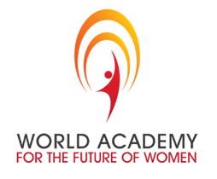

WAFW MENTOR INTRODUCTION

Founded in 2009, The World Academy for the Future of Women’s purpose is to advanced and accelerate women’s leadership worldwide. It is an action leadership program where members discover their passion, purpose, and path to success. World Academy members apply and are accepted based on their commitment to impact their families, communities, countries and the world, as leaders with integrity and a high level of social conscious. They achieve this through 8-10 hours of weekly seminars, labs, coaching, open forum and WAFW projects based on the United Nations Sustainable Development Goals.

By intention, WAFW members do NOT earn university credit for this program, because we believe that leadership is for the benefit of humanity, and not for personal credit. None of our members pay any fees to participate in our program. We only ask for their commitment to participate fully in their classes and the curriculum and to focus on women achieving social justice, gender equality and human dignity.

Our WAFW locations are in China at Sias University in Henan Province, at the University of Liberal Arts Bangladesh (ULAB) in Dhaka, and in Nepal at Southwestern College in Kathmandu. All campuses have been closed since the COVID-19 Pandemic and we are currently transferring our on-site curriculum to an on-line delivery model. This does not reflect our action leadership model that is heavily focused on relationship and engagement with the WAFW facilitators who are volunteers trained to deliver the curriculum modules on site. Missing this personal and powerful interaction is an issue we want to address through identifying mentors to support these young leaders in achieving their outcomes and engage with the WAFW Oath and Operating Principles that are fundamental to their action leadership development. In China, many of the members come from rural communities where they may be the only person in their village to speak English. With the mandated quarantine, many of them have not spoken English in months and their English language skills have declined. In Bangladesh, they are coping with higher levels of depression and domestic violence. In Nepal, we are beginning on a new campus and introducing these young members to a new way of seeing and being a leader. We are committed to maintaining personal contact with them and having them recognize and identify how women’s leadership is fundamental to achieving social justice, gender equality and human dignity. We also have male members in the Men’s Academy for the Future of Women who support the advancement of women’s leadership. To accomplish this goal, we are seeking 150 people to volunteer as WAFW Mentors to these college women and men.

Qualifications to be a mentor:
- Ability to engage with the member in discussions related to their WAFW leadership curriculum.
- Fluent English speaker
- Access to Zoom Meeting, Ding Talk, VooV Meeting, WeChat, Skype or WhatsApp (pending location)
- Strong conversation skills
- Command of grammar and ability to coach members on use of English
- Availability to participate in a monthly one hour facilitated Mentor Call to give feedback and ideas to incorporate in sessions with your WAFW member.

Your Commitment: to initiate and participate in 2 (half hour) conversations per week with a member of the WAFW. These conversations will be scheduled to start as soon as we have received and vetted your application and you have participated in an interview with us to clarify any concerns regarding your commitment.

Conversation topics to address: purpose, passion, vision, Oath, Operating Principles, career goals, leadership, as well as school, family life, personal goals, interests and hobbies. The conversations you generate can be catalytic to accelerating possibilities for them to see a bigger and meaningful life. You can widen their vision for what is possible and strengthen their capacity to lead. We will send you the World Academy Oath and Operating Principles for content you can include. We will engage with you as members grow and development. We are always available to assist and support your mentorship.

Conversation topics to avoid: Religion and politics

CONTACT INFORMATION
Jessie Huang (86+137 2165 9639) PACIFIC TIME hjhjessie@163.com
WAFW.org
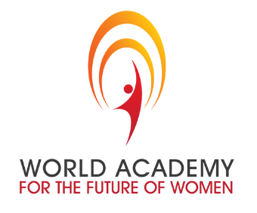

MENTOR APPLICATION
For
The World Academy for the Future of Women

Name: ________________________________________________________________________________________________

Address: ______________________________________________________________________________________________

______________________________________________________________________________________________

Country:_______________________________________________________________________________________________

Phone number:_________________________________________________________________________________________

Email:_________________________________________________________________________________________________

One Page Biography Information: Please attach.

Position Statement: What interests you about being a mentor to these young university World Academy for the Future of Women?

THERE ARE 2 LEVELS OF MENTOR AGREEMENT (Please check the one you wish to volunteer and commit to fulfilling.)

- ____ Begin immediately and continue through the academic school year ending July 1, 2021.

- ____ Begin immediately and continue through the academic school year ending December 31, 2021.

RETURN THIS APPLICATION TO JESSIE HUANG by e-mail at hjhjessie@163.com for immediate response and engagement. Thank you for your commitment to accelerating women’s leadership worldwide.

